2. Add Two Numbers
You are given two non-empty linked lists representing two non-negative integers. The digits are stored in reverse order, and each of their nodes contains a single digit. Add the two numbers and return the sum as a linked list.
You may assume the two numbers do not contain any leading zero, except the number 0 itself.

Example 1:
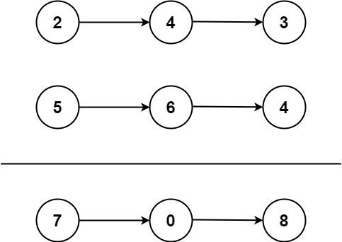
Input: l1 = [2,4,3], l2 = [5,6,4]
Output: [7,0,8]
Explanation: 342 + 465 = 807.
Example 2:
Input: l1 = [0], l2 = [0]
Output: [0]
Example 3:
Input: l1 = [9,9,9,9,9,9,9], l2 = [9,9,9,9]
Output: [8,9,9,9,0,0,0,1]

Constraints:
- The number of nodes in each linked list is in the range [1, 100].
- 0 <= Node.val <= 9
- It is guaranteed that the list represents a number that does not have leading zeros.
CODE:
class Solution:
def addTwoNumbers(self, l1, l2):
dummy = ListNode(0)
current = dummy
carry = 0

while l1 or l2 or carry:
val1 = l1.val if l1 else 0
val2 = l2.val if l2 else 0

total = val1 + val2 + carry
carry = total // 10
digit = total % 10

current.next = ListNode(digit)
current = current.next

if l1:
l1 = l1.next
if l2:
l2 = l2.next

return dummy.next

